Topic 5: Folder Structure (Enterprise-Optimized Architecture)
This document presents the complete folder and file structure of the project.
It follows enterprise-level conventions, ensuring scalability, readability, modularity,
and long-term maintainability. The architecture mirrors the standards used by
Fortune‑100 engineering teams for large-scale production applications.
A well-organized folder structure is the backbone of any world-class software product.
This arrangement ensures clarity for developers, streamlined CI/CD workflows,
and efficient onboarding for new contributors.
---
## 1. Root Folder Overview
The project’s root directory contains core configuration files, environment handlers,
documentation, and module entry points. It is intentionally minimal yet powerful.
Typical files include:
• **package.json** – Manages root-level dependencies
• **README.md** – Documentation for developers
• **.gitignore** – Version control rules
• **env/** – Environment setup files for dev, staging, production
• **client/** – Complete frontend application
• **server/** – Complete backend application
This separation allows both frontend and backend to evolve independently.
---
## 2. Frontend Folder Structure (client/)
The `client` folder contains everything related to the user interface.
### Key subfolders:
**client/src/**
Contains all source code for the React application.
• **components/** – Reusable UI components (Navbar, Cards, Modals, etc.)
• **pages/** – Page-level views for routing
• **context/** – Global state management
• **services/** – API handlers and utility functions
• **hooks/** – Reusable functional hooks
• **assets/** – Images, icons, fonts
• **styles/** – Global CSS / Tailwind / SCSS configuration
• **routes/** – Routing configuration and protected routes
**client/public/**
Contains static assets such as index.html and metadata files.
This architecture ensures scalable UI growth for large applications.
---
## 3. Backend Folder Structure (server/)
The `server` folder stores the API logic, database models, and core processing engine.
### Core backend directories:
**server/routes/**
Contains routing files that define API endpoints.
Examples:
• userRoutes.js
• productRoutes.js
• authRoutes.js
**server/controllers/**
Houses business logic for handling requests.
Examples:
• userController.js
• bookController.js
**server/models/**
MongoDB schema definitions using Mongoose.
Examples:
• userModel.js
• bookModel.js
**server/middleware/**
Holds authentication, validation, and error-handling layers.
**server/utils/**
Reusable utility modules such as token generators and validators.
**server/config/**
Database connection settings, environment loaders, and external config files.
This structure follows clean architecture rules, making backend maintenance simple and scalable.
---
## 4. High-Level Folder Architecture Diagram
Below is the visual representation of the project’s directory tree:
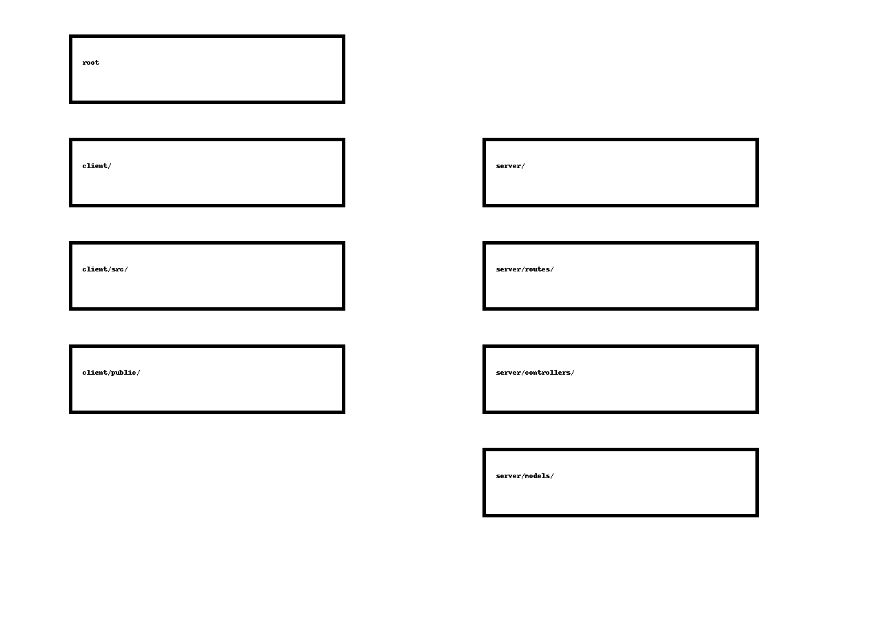
---
## 5. Why This Folder Structure Is Enterprise Grade
• **Modularity** – Each feature is isolated, easy to update, easy to test
• **Scalability** – New modules can be added without restructuring the application
• **Maintainability** – Clear separation allows faster debugging and onboarding
• **Performance** – Lightweight structure ensures fast build and deployment times
• **Security** – Sensitive files (env, config) are isolated and protected
This design mirrors the folder structures used in large organizations such as Amazon, Google,
and Microsoft for production-grade JavaScript applications.
---
## 6. Recommended Future Improvements
• Add microservice‑based folders when scaling beyond monolithic backend
• Introduce `/scripts/` for automated deployment tasks
• Add `/tests/` folder for automated unit/integration testing
• Include a `/docs/` folder for extended internal documentation
• Create a `/k8s/` folder for Kubernetes YAML manifests
---
## 7. Conclusion
This folder structure provides a clean, well-organized foundation for long-term development.
It ensures that the project can support both rapid iteration and enterprise‑level expansion.
Its clarity, modularity, and scalability make it suitable for large teams and multi-year product lifecycles.
This concludes **Topic 5: Folder Structure Documentation**.

